**SEA College of Science,Commerce and Arts**

**“HAND GESTURE RECOGNIZER”**

A project report submitted in partial fulfillment of the requirement for

Bachelor’s in Computer Application, Sixth semester under Bengaluru North University during the academic year 2021-2024.

**Bachelor's in Computer Application**

**Submitted By**

Prince tom jacob (U19UU21S0061)

Adil Jamal (U19UU21S0062)

Ibrahim Khaleel A(U19UU21S0070)

**Under the Guidance of**

Mrs.Ramya M

# Assistant Professor



**SEA College of Science, Commerce and Arts**

Bengaluru North University

Ekta Nagar,Near Ayyappanagar Circle,

Devasandra Main Road, Vigronagar

Post, K.R.Puram,Bangalore-560049.

**SEA College of Science, Commerce &Arts Bengaluru North University**



# Certificate

This is to certify that the project entitled **“HAND GESTURE RECOGNIZER”,** is a Bonfied work done by **Prince tom Jacob(U19UU21S0061), Adil jamal(U19UU21S0062), Ibrahim Khaleel A(U19UU21S0070)** Under of guidance of **Mrs.Ramya M, Assistant Professsor of the Department,** which is in partial fulfillment of the requirement for the award of Bachelor’s in Computer Application from Bengaluru North University.

**Internal Guide Head of the Department**

**Principal**

**Examiners:**

**1) Date:**

**Place: Bangalore**

**2)**

## Acknowledgment

Above all, we want to thank God Almighty for the blessings, health, wisdom, knowledge, and strength he has given to us. It is only by his will that we are able to start and complete this project.

We wish to express our sincere gratitude to the Late A. Krishnappa, the chairman of South East Asian Educational Trust for providing good infrastructure and adequate equipment’s for the proper functioning of the institution.

We also thank **Dr. Muthe Gowda T N,** the Principal of SEA College of Science, Commerce and Arts for his tireless effort in managing the College making sure that everything runs in proper order.

We sincerely thank **Mrs. Santhi Theja P,** the Head of the Department for her constant support, advice, and guidance which greatly contributed to the successful completion of this project.

We also sincerely thank **Mrs. M Ramya,** Assistant Professor who is the guide of our project for her support. We also wish to express our gratitude the all the staff in the Computer Science Department of their support, concern and encouragement not only to the project but also in our studies.

We also want to thank our parents for their guidance, support, encouragement, advice and prayers. And also, for providing all the materials we need, not only for our studies but also for our well-being if not for them, we will not be here today.

We also want to thank our brothers and sisters for their support and advice which helped in the successful completion of this project.

**Table of Contents**

|  |  |  |
| --- | --- | --- |
| **S.No** | **Contents** | **Page No.** |
| 1 | Synopsis | 7 |
| 2 | Introduction | 9 |
| 3 | System Analysis | 16 |
| 4 | Technologies Used | 21 |
| 5 | General Description | 26 |
| 6 | Functional and Non-functional Requirement | 31 |
| 7 | System Architecture | 36 |
| 8 | System Model | 47 |
| 9 | Result | 56 |
| 10 | Screenshot | 57 |
| 11 | Coding | 61 |
| 12 | Conclusion | 84 |
| 13 | Limitation | 85 |
| 14 | Future Enhancement | 86 |
| 15 | Bibliography | 87 |

**Table of Figure**

|  |  |  |
| --- | --- | --- |
| **S.No** | **Figure** | **Page No.** |
| 1 | Tensor flow model | 23 |
| 2 | Integration | 25 |
| 3 | System architecture | 36 |
| 4 | ER Diagram | 46 |

### 1. SYNOPSIS

1. **Title of Project:**

Hand gesture recognizer

1. **Objective:**

The objective of this project is to develop a robust and accurate sign language detection system using machine learning techniques. This system will be capable of recognizing and interpreting various sign gestures and translating them into corresponding text or spoken language, facilitating effective communication between individuals who are deaf or hard of hearing and the general population. To achieve this objective, we will collect and prepare a diverse dataset of sign language gestures, select an appropriate machine learning model architecture, train and evaluate the model's performance, develop a realtime sign language detection system, create an intuitive user interface, ensure deployment and accessibility across various platforms, and continuously evaluate and 10 10 improve the system based on user feedback and advancements in the field. Through these objectives, we aim to contribute to inclusive communication and enhance accessibility for individuals with hearing impairments.

1. **Description:**

The Sign Language Detection project aims to develop a robust and accurate system for interpreting and understanding sign language gestures using machine learning techniques. This project is motivated by the need to bridge the communication gap between individuals who use sign language and those who do not understand it. By leveraging advances in computer vision and machine learning, the project seeks to enable real-time sign language interpretation, improving inclusivity and accessibility for individuals with hearing impairments.

**Modules:**

AdminModule

User Module

1. **System Requirement Specification(SRS):**

**Hardware Requirement Specification:**

Processor : Standard processor with a speed of 1.6 GHz

RAM : 4 GB

Hard Disk : 256 GB

Monitor : Standard Color Monitor

Keyboard : Standard Keyboard

Mouse : Standard Mouse

**Software Requirement Specification:**

Operating System : Windows, macOS, or Linux, depending on the development environment and compatibility with the required software tools.

Database : MySQL

Browser : Internet Explorer

**F) Used Technologies:**

Front End : HTML,CSS,JavaScript

Web Technologies : Node js, tensorflow.js

Back End : Node js

### 2. Introduction

#### Background

#### The Sign Language Detection project aims to develop a robust and accurate system for interpreting and understanding sign language gestures using machine learning techniques. This project is motivated by the need to bridge the communication gap between individuals who use sign language and those who do not understand it. By leveraging advances in computer vision and machine learning, the project seeks to enable real-time sign language interpretation, improving inclusivity and accessibility for individuals with hearing impairments.

#### Goal and Objective Goal:

#### The goal of this project is to develop a robust and accurate sign language detection system using machine learning techniques. The system will be able to recognize and interpret various sign gestures and translate them into corresponding text or spoken language, enabling effective communication between individuals who are deaf or hard of hearing and the general population.

#### Objective:

#### The objective of this project is to develop a robust and accurate sign language detection system using machine learning techniques. This system will be capable of recognizing and interpreting various sign gestures and translating them into corresponding text or spoken language, facilitating effective communication between individuals who are deaf or hard of hearing and the general population. To achieve this objective, we will collect and prepare a diverse dataset of sign language gestures, select an appropriate machine learning model architecture, train and evaluate the model's performance, develop a realtime sign language detection system, create an intuitive user interface, ensure deployment and accessibility across various platforms, and continuously evaluate and 10 10 improve the system based on user feedback and advancements in the field. Through these objectives, we aim to contribute to inclusive communication and enhance accessibility for individuals with hearing impairmentsReason for the Project

**Hand Gesture Recognition Project: Comprehensive Overview:**

The hand gesture recognition project is an ambitious endeavor that seeks to redefine the way humans interact with technology, leveraging the natural, expressive nature of hand movements to create a more intuitive and immersive user experience. This technology harnesses advanced computer vision and machine learning algorithms to interpret and act upon gestures, offering a range of applications across various domains.

**Enhanced Human-Computer Interaction:**

One of the primary motivations behind the hand gesture recognition project is to advance human-computer interaction (HCI). Traditional input devices like keyboards, mice, and touchscreens often require users to adapt their natural behaviors to fit the constraints of the technology. Hand gesture recognition shifts this paradigm by allowing users to communicate with devices through natural, fluid movements. This can lead to more intuitive and efficient interactions, where users can perform complex commands and control applications simply by moving their hands in specific ways.

For example, in creative applications such as digital art and design, gesture recognition can enable artists to manipulate virtual tools and canvases with gestures that mimic real-world actions, such as painting strokes or sculpting movements. This can enhance the creative process by providing a more direct and expressive means of interaction. Similarly, in gaming, gesture-based controls can offer a more immersive experience, where players use physical movements to control their avatars or interact with the game environment, enhancing engagement and realism.

**Applications in Virtual and Augmented Reality:**

The integration of hand gesture recognition into virtual reality (VR) and augmented reality (AR) systems represents a significant leap forward in creating more immersive and interactive experiences. In VR, users can interact with a fully digital environment using natural hand movements, allowing them to manipulate objects, navigate through spaces, and perform tasks as if they were in the physical world. This can improve the sense of presence and realism, making VR experiences more compelling and effective for applications ranging from gaming to training simulations.

In AR, gesture recognition enables users to interact with digital overlays and virtual elements superimposed on their physical surroundings. For instance, users can use hand gestures to control virtual interfaces or manipulate digital objects that appear in their field of view. This can enhance applications in fields like education, where interactive AR experiences can facilitate hands-on learning, or in retail, where customers can engage with virtual product displays through gestures.

Advancements in Healthcare

In healthcare, hand gesture recognition has the potential to improve both patient and provider experiences. In sterile environments such as operating rooms, gesture-based controls can minimize the need for physical contact with surfaces, thereby reducing the risk of contamination. Surgeons and medical staff can operate equipment, access information, and control devices without touching screens or buttons, enhancing both hygiene and efficiency.

For patients, gesture recognition technology can offer new ways to interact with assistive devices and healthcare applications. For instance, patients with limited mobility can use hand gestures to control home automation systems, communicate with caregivers, or access therapeutic exercises, promoting greater independence and improving quality of life.

**Accessibility and Inclusion:**

The project also has a strong focus on accessibility and inclusivity. Hand gesture recognition can provide alternative input methods for individuals with physical disabilities, offering new ways to interact with technology and access digital content. For example, individuals with motor impairments can use gestures to control devices, participate in virtual environments, or communicate more effectively. This can help bridge communication gaps and create more inclusive technological solutions that cater to diverse user needs.

**Smart Home and Wearable Technologies:**

In the realm of smart home technology, gesture recognition can enhance the control of home automation systems, making interactions more intuitive and seamless. Users can perform gestures to adjust lighting, control appliances, or manage security systems without needing to use physical controls or voice commands. This can simplify the user experience and integrate technology more seamlessly into daily life.

Wearable devices equipped with gesture recognition capabilities can also provide hands-free operation and context-aware functionalities. For example, smartwatches and fitness trackers can use gesture recognition to navigate menus, control media playback, or track physical activities. This can improve user convenience and expand the range of applications for wearable technology.

**Future Prospects and Challenges:**

Looking ahead, the hand gesture recognition project faces several challenges and opportunities. Technical challenges include achieving high accuracy and reliability in gesture recognition, handling varying lighting conditions and user contexts, and ensuring that the technology is responsive and adaptable. Additionally, there is a need for continuous refinement of algorithms and models to improve performance and user experience.

On the opportunity front, the continued evolution of machine learning and computer vision technologies promises to enhance the capabilities of gesture recognition systems. Innovations in sensor technology, such as advanced cameras and depth sensors, can further improve gesture tracking and interpretation. As the technology matures, it has the potential to unlock new applications and transform industries by offering more natural and interactive ways for users to engage with technology.

**Conclusion:**

In summary, the hand gesture recognition project represents a significant advancement in how we interact with technology. By enabling more natural, intuitive, and immersive interactions, this technology has the potential to enhance user experiences across various domains, including virtual and augmented reality, healthcare, accessibility, and smart home environments. As the project progresses, it will continue to push the boundaries of human-computer interaction, making technology more accessible, inclusive, and responsive to the needs of users.

### 3. System Analysis

## System Analysis for a Hand Gesture Recognition Project

## The system analysis phase of a hand gesture recognition project is crucial for understanding the technical requirements, design considerations, and functional specifications needed to build an effective and efficient gesture recognition system. This phase involves breaking down the project into manageable components, analyzing user requirements, and defining system architecture and performance metrics. Here’s a detailed breakdown of the system analysis for a hand gesture recognition project0

#### Requirements Analysis:

Functional Requirements:Gesture Recognition Accuracy: The system must accurately recognize a variety of hand gestures with high precision. It should be able to distinguish between similar gestures and handle variations due to different users or environmental conditions.Real-Time Processing: The system should process gestures in real-time, with minimal latency, to ensure smooth and responsive user interactions.

User Interface (UI): A clear and intuitive UI is needed for users to see feedback about recognized gestures and system status.

Customization: The system should allow users to define and customize their own gestures for specific commands or actions.

Integration: The system must be capable of integrating with other software or hardware components, such as virtual reality environments, smart home systems, or assistive devices.

**1.Non-Functional Requirements:**

Performance: The system should operate efficiently, with optimized computational resource usage to ensure responsiveness without significant delays.Scalability: The system should be scalable to accommodate varying numbers of users and gestures.Security: Measures should be in place to protect user data and ensure privacy, especially if personal data is being collected or processed.Reliability: The system must be robust and reliable, minimizing the likelihood of errors or crashes.

##### 2. System Architecture

Hardware Components:Sensors and Cameras: The system typically requires cameras or depth sensors to capture hand movements. Options include RGB cameras, depth sensors (e.g., Intel RealSense), or specialized gesture recognition hardware.

Processing Unit: A powerful processing unit, such as a computer or embedded system, is needed to handle data processing and gesture recognition algorithms. This unit must have sufficient computational power and memory.

Software Components:

Gesture Recognition Algorithms: These are the core of the system, involving machine learning models and computer vision techniques to interpret hand gestures. Common algorithms include convolutional neural networks (CNNs) for image-based recognition and recurrent neural networks (RNNs) for sequence-based gestures.

Data Processing Pipeline: This includes modules for data acquisition, preprocessing, gesture detection, and recognition. Data preprocessing might involve noise reduction, normalization, and feature extraction.User Interface (UI) Software: The UI component allows users to interact with the system, providing feedback on recognized gestures and system status.

**Integration Components**:

APIs and SDKs: For integration with external systems or applications, the system may need to provide APIs or SDKs. These interfaces facilitate communication and interaction with other software or hardware.

Database: If the system stores user data, configurations, or gesture definitions, a database is required for data management and retrieval.

**3. System Design**

Data Flow Design:Input: Raw data is captured by sensors or cameras and sent to the processing unit.Processing: The data is processed through various stages, including noise reduction, feature extraction, and gesture classification.

Output: Recognized gestures are translated into commands or actions and communicated to the user interface or external systems.Algorithm Design:Gesture Detection: Techniques for detecting hand gestures from raw sensor data. This might include background subtraction, motion detection, or spatial-temporal analysis.

Gesture Classification: Algorithms to classify detected gestures into predefined categories. This typically involves training machine learning models with labeled gesture data.

Error Handling: Mechanisms to handle misclassifications or ambiguous gestures, including feedback loops for user correction or system recalibration.

**4. Performance Metrics**

Accuracy: Measure how accurately the system recognizes gestures compared to the expected outcomes. This involves metrics such as precision, recall, and F1-score.

Latency: Evaluate the time delay between gesture input and system response. Low latency is critical for real-time applications.

Robustness: Assess the system’s ability to handle varying conditions, such as different lighting environments, hand sizes, or user movements.

Scalability: Test the system’s performance under different loads, including the number of simultaneous users or gestures.

User Satisfaction: Collect feedback from users to gauge the ease of use, responsiveness, and overall satisfaction with the system.

**5. System Constraints and Considerations**

Environmental Factors: The system’s performance can be affected by lighting conditions, background noise, and physical space. Considerations must be made to handle these variables or design the system to function effectively in various environments.

User Diversity: The system should accommodate a wide range of hand sizes, shapes, and movement styles. This may involve adapting gesture recognition models to different user profiles.

Privacy and Security: Implement measures to protect user data and ensure secure data transmission, especially if personal or sensitive information is involved.

Technical Limitations: Address limitations related to hardware capabilities, such as sensor resolution or processing power, and develop solutions to mitigate these constraints.ConclusionThe system analysis phase is foundational for the successful development of a hand gesture recognition project. By thoroughly analyzing requirements, designing system architecture, and considering performance metrics and constraints, the project can achieve its goals of providing an intuitive, accurate, and responsive gesture recognition experience. This analysis not only guides the development process but also ensures that the final system meets user needs and performs effectively in real-world scenarios.

### 4 TECHNOLOGY USED

### Software Requirement:

Node.js is a JavaScript runtime built on Chrome's V8 engine, designed to execute JavaScript code server-side. It features an event-driven, non-blocking I/O model, making it efficient and scalable for handling numerous concurrent connections. Node.js is widely used for web servers, APIs, real-time applications like chat and gaming, and microservices. Its package manager, npm, provides access to a vast ecosystem of libraries and tools, simplifying development. While its single-threaded nature excels in performance and scalability, CPU-intensive tasks can be a limitation. Node.js is cross-platform and suitable for building both server-side applications and command-line tools.

**TensorFlow**:

Version: The latest stable version of TensorFlow. Description: TensorFlow is an open-source machine learning framework with a wide range of functionalities, including model training, optimization, and deployment. It provides a high-level API for building and training neural networks, making it suitable for developing and fine-tuning sign language detection models.

**Flask:**

The latest stable version of Flask. Description: Flask is a lightweight web framework written in Python. It allows for the development of web-based user interfaces and hosting of the sign language detection system. Flask provides routing capabilities, template rendering, and integration with various web technologies.

**OpenCV:**

Version: The latest stable version of OpenCV. 18 18 Description: OpenCV (Open Source Computer Vision Library) is a computer vision and image processing library. It offers a wide range of functions for image and video processing, such as capturing video streams, image resizing, normalization, and applying various filters. OpenCV will be used for preprocessing video frames in the sign language detection system. ● By ensuring the availability and compatibility of these software components, developers can leverage their functionalities to build a robust and efficient sign language detection system.

**Image Processing Methods** .

Image Acquisition: Utilize OpenCV (cv2) library to capture images or video frames from the user's camera. Use OpenCV's functions, such as cv2.VideoCapture(), to access the camera feed and retrieve frames. Image Preprocessing: Convert the acquired images to the appropriate format for further processing using OpenCV. Resize the images to a consistent size suitable for the model input. Use the cv2.resize() function to resize images while maintaining the aspect ratio. Normalize the pixel values of the images to a common range (e.g., 0 to 1) using NumPy. Divide the pixel values by the maximum pixel value (e.g., 255) to achieve normalization. MediaPipe Integration: 19 19 Integrate MediaPipe into the image processing pipeline to perform gesture recognition and hand tracking. Use MediaPipe's hand tracking module (mediapipe.solutions.hands) to detect and track hands in the acquired images. Extract relevant hand landmarks using MediaPipe, which provides a set of 21 3D hand keypoints representing different parts of the hand.

**TensorFlow Model Inference:**

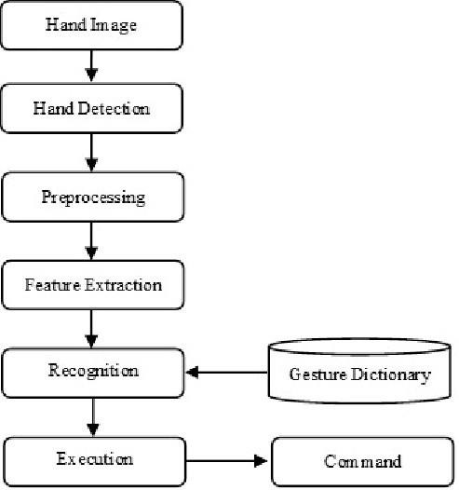

(FIG 1.1)

Load the trained TensorFlow model for sign language detection using tf.keras.models.load_model(). Utilize the processed image data and hand landmarks from MediaPipe as input to the TensorFlow model for inference. Combine the image data and hand landmarks to create the input tensor. Perform forward-pass computations on the model to obtain predictions for sign language gestures using the model.predict() function. Post-processing and Visualization: 20 20 Interpret the predictions from the TensorFlow model and associate them with corresponding sign language gestures or meanings. Use OpenCV and MediaPipe to overlay visual indicators or annotations on the processed images. For example, you can draw bounding boxes around detected hands using OpenCV's cv2.rectangle() function or display text labels indicating recognized gestures. Real-time Application: Implement the image processing pipeline within a real-time application using appropriate looping and threading mechanisms. Continuously process incoming frames or images from the camera in real-time and update the visualizations accordingly. Display the processed images or video feed with overlays in a userfriendly manner using OpenCV's cv2.imshow() and cv2.waitKey() functions

**Integration with MediaPipe:**

Utilize the MediaPipe framework to integrate the trained TensorFlow model into the sign language detection system. Leverage MediaPipe's video processing capabilities to capture and preprocess live video streams for real-time inference.

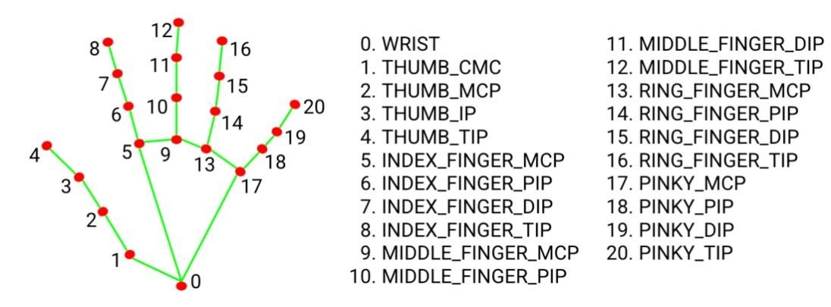  
**(FIG 1.2)**

To produce a web application based system that allow user to detect the sentiment and personality first the user have to register and login into application. It’s show almost high accuracy and very easy to used.

#### 5.General Description

A hand gesture recognizer is a sophisticated system designed to interpret hand movements and gestures to control devices, interact with applications, or provide input in various contexts. It typically involves several integrated technologies to capture, process, and understand hand gestures. Here's a more detailed overview:

### ****1. System Overview****

**Components**:

* **Sensors and Cameras**: Capture data about hand position, movement, and orientation. Commonly used devices include standard webcams, depth cameras (such as Microsoft Kinect), or specialized gesture sensors (like Leap Motion).
* **Processing Unit**: Analyzes the captured data to detect and interpret gestures. This could involve on-device processing or offloading to a server or cloud service.
* **Output Interface**: Executes actions based on recognized gestures. This can include controlling applications, sending commands, or providing feedback to the user.

### ****2. Data Capture****

**Types of Data**:

* **2D Images**: Captured by standard cameras, used for gesture recognition in a planar view.
* **3D Depth Information**: Provided by depth cameras or sensors, offering additional spatial information about hand position and movement.
* **Motion Data**: Collected from accelerometers or gyroscopes to track hand movements and orientation.

### ****3. Image and Gesture Processing****

**Preprocessing**:

* **Background Removal**: Techniques like background subtraction or color segmentation isolate the hand from the background.
* **Normalization**: Adjusting the image to account for lighting variations and ensure consistent recognition performance.

**Feature Extraction**:

* **Hand Landmark Detection**: Identifies key points on the hand such as fingertips, knuckles, and palm. Methods include using pre-trained models like MediaPipe or OpenPose.
* **Contour Detection**: Identifies the hand’s outline and shape, useful for recognizing static gestures.

**Gesture Recognition**:

* **Machine Learning Models**: Supervised learning algorithms, such as support vector machines (SVMs) or decision trees, classify gestures based on trained data.
* **Deep Learning Models**: Convolutional Neural Networks (CNNs) and Recurrent Neural Networks (RNNs) are used for more complex gesture recognition tasks, handling both static and dynamic gestures.
* **Template Matching**: Compares the detected hand features with stored templates of known gestures to find the best match.

### ****4. Action Mapping and Execution****

**Mapping Gestures**:

* **Predefined Actions**: Each recognized gesture is mapped to a specific action, such as navigating a menu or executing a command.
* **Contextual Actions**: Gestures may trigger different actions based on the context or state of the application.

**Feedback**:

* **Visual Feedback**: Displays feedback on the screen to confirm gesture recognition or provide additional information.
* **Haptic Feedback**: Provides physical sensations (e.g., vibrations) to confirm gesture actions or interactions.

### ****5. Applications****

**Human-Computer Interaction**:

* **User Interfaces**: Allows users to interact with software applications or devices through gestures, enhancing accessibility and user experience.

**Virtual Reality (VR) and Augmented Reality (AR)**:

* **Immersive Experiences**: Enables natural interaction within VR and AR environments by recognizing hand gestures.

**Assistive Technology**:

* **Accessibility**: Provides alternative input methods for individuals with disabilities, facilitating interaction with technology.

**Gaming**:

* **Gesture-Based Controls**: Adds an immersive dimension to gaming by allowing players to control actions through hand movements.

### ****6. Challenges and Considerations****

**Accuracy**:

* **Variability in Gestures**: Different users may perform the same gesture in various ways, requiring robust recognition algorithms.
* **Environmental Factors**: Lighting conditions, background clutter, and camera angles can affect recognition accuracy.

**Real-Time Processing**:

* **Latency**: Ensuring that gestures are recognized and actions are executed with minimal delay for a smooth user experience.

**Complex Gestures**:

* **Gesture Variability**: Recognizing complex or dynamic gestures accurately, which may involve multiple hand movements or changes in position.

**User Training**:

* **Customization**: Adapting the system to individual users or specific applications may require training or calibration to improve recognition accuracy.

#### 6 FUNCTIONAL AND NON FUNCTIONAL REQUIREMENTS

When designing a hand gesture recognizer, it's crucial to define both functional and non-functional requirements to ensure the system meets its intended goals and performs efficiently. Here’s a detailed breakdown of both types of requirements:

### Functional Requirements

Functional requirements define the specific functionalities and capabilities that the hand gesture recognizer must have. These requirements detail what the system should do and how it should behave.

1. **Gesture Detection and Recognition**
   * **Gesture Detection**: The system must detect the presence of a hand in the camera's field of view.
   * **Gesture Recognition**: The system must accurately recognize and classify a predefined set of hand gestures (e.g., thumbs up, fist, swipe).
2. **Real-Time Processing**
   * **Low Latency**: The system must process and recognize gestures in real-time with minimal delay to provide immediate feedback or execute commands.
3. **Multi-Gesture Support**
   * **Gesture Variety**: The system should support a range of gestures, including static (e.g., open hand, closed fist) and dynamic (e.g., swipes, circles) gestures.
4. **Contextual Awareness**
   * **Contextual Actions**: The system should be able to map gestures to different actions based on the application's context or state.
5. **User Feedback**
   * **Visual Feedback**: The system should provide visual feedback (e.g., on-screen indicators) to confirm gesture recognition.
   * **Auditory Feedback**: Optionally, the system can provide sound cues for feedback.
6. **Customization and Training**
   * **Gesture Customization**: Users should be able to define and train the system with new gestures.
   * **User Calibration**: The system should allow for user-specific calibration to improve recognition accuracy.
7. **Error Handling**
   * **Error Detection**: The system should be able to detect and handle errors or ambiguities in gesture recognition.
   * **Fallback Mechanisms**: Provide fallback options or prompts if the gesture is not recognized.
8. **Integration**
   * **API and Interfaces**: The system must provide APIs or interfaces to integrate with other software or hardware systems.

### ****Non-Functional Requirements****

Non-functional requirements define the overall qualities and constraints of the system, such as performance, reliability, and usability.

1. **Performance**
   * **Processing Speed**: The system must handle gesture recognition tasks efficiently, ensuring high performance under varying conditions.
   * **Scalability**: The system should be scalable to support increasing numbers of gestures or users without a significant performance degradation.
2. **Accuracy**
   * **Recognition Accuracy**: The system must achieve a high accuracy rate in recognizing and differentiating between gestures.
   * **False Positives/Negatives**: Minimize the rate of false positives (incorrectly recognizing a gesture) and false negatives (failing to recognize a gesture).
3. **Usability**
   * **Ease of Use**: The system should be intuitive and easy for users to interact with and understand.
   * **User Experience**: Ensure that the gesture recognition is smooth and natural, enhancing the overall user experience.
4. **Reliability**
   * **Robustness**: The system should be reliable and perform consistently across different environments and lighting conditions.
   * **Error Recovery**: Implement mechanisms for recovering from errors and maintaining functionality under unexpected conditions.
5. **Compatibility**
   * **Platform Compatibility**: Ensure the system is compatible with various hardware platforms and operating systems.
   * **Integration with Existing Systems**: Seamlessly integrate with existing software and hardware systems as required.
6. **Security**
   * **Data Privacy**: Ensure that any data captured (such as images of users' hands) is securely handled and stored.
   * **Access Control**: Implement mechanisms to control access to the gesture recognition system and its data.
7. **Maintainability**
   * **Ease of Maintenance**: The system should be designed for easy maintenance and updates, allowing for modifications and improvements over time.
   * **Documentation**: Provide comprehensive documentation for developers and users to facilitate understanding and troubleshooting.
8. **Scalability**
   * **Adaptability**: The system should be adaptable to different scales of deployment, from small-scale personal devices to large-scale installations.
9. **Cost**
   * **Cost-Effectiveness**: The development and operational costs should be justified by the benefits provided by the gesture recognition system.
10. **Power Consumption**
    * **Efficiency**: Ensure that the system operates efficiently, especially if it is intended for battery-powered or mobile devices.

By addressing these functional and non-functional requirements, you can design a hand gesture recognizer that not only meets the intended use cases but also performs effectively and reliably in real-world scenarios.

Top of Form

Bottom of Form

**7 SYSTEM ARCHITECTURE**

#### The architecture of a hand gesture recognizer is designed to effectively capture, process, and interpret hand gestures to provide intuitive and responsive user interactions. Each component plays a crucial role in ensuring the system functions smoothly and meets the desired performance and usability goals.

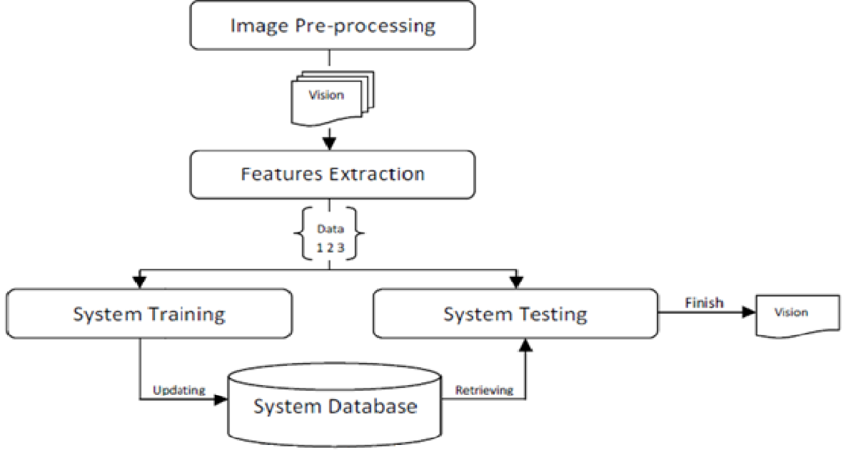

(FIG1.2)

**8 SYSTEM MODEL**

A system model for a hand gesture recognizer typically involves several key components and steps to process and interpret hand gestures. Here’s a high-level overview of such a system:

### ****Data Collection****

**a. Sensor Input**:

* **Cameras**: RGB cameras, depth cameras (like Intel RealSense or Microsoft Kinect).
* **Sensors**: Wearable devices with accelerometers, gyroscopes, or other sensors.

**b. Data Types**:

* **Images/Videos**: Raw video frames or images of hands.
* **Sensor Data**: Raw data from wearable sensors, such as motion tracking devices.

### 2. ****Preprocessing****

**a. Image Processing**:

* **Noise Reduction**: Filter out noise from the image or sensor data.
* **Normalization**: Standardize the size, orientation, and lighting conditions.
* **Segmentation**: Isolate the hand from the background.

**b. Data Augmentation** (for training):

* Apply transformations to increase the variety of training data, such as rotation, scaling, and color adjustment.

### ****Feature Extraction****

### ****a. Hand Detection****:

* **Segmentation Algorithms**: Techniques like color-based segmentation or background subtraction.
* **Pose Estimation**: Detect hand landmarks or keypoints using models like OpenPose or MediaPipe.

**b. Feature Representation**:

* **Keypoints**: Coordinates of specific points on the hand.
* **Contours**: Shape and outline of the hand.
* **Motion Vectors**: Changes in hand position or orientation over time.

### 4. ****Gesture Recognition****

**a. Classification Algorithms**:

* **Machine Learning Models**: Support Vector Machines (SVM), k-Nearest Neighbors (k-NN).
* **Deep Learning Models**: Convolutional Neural Networks (CNNs), Recurrent Neural Networks (RNNs), or Transformers.

**b. Temporal Analysis** (if applicable):

* **Temporal Models**: Long Short-Term Memory (LSTM) networks or 3D CNNs for recognizing gestures over time.

### 5. ****Post-processing****

**a. Gesture Mapping**:

* **Mapping Outputs**: Translate the recognized gesture into actions or commands.
* **Contextual Adjustment**: Adjust based on the context or user profile.

**b. Error Handling**:

* **Filtering**: Smooth out erroneous or ambiguous gestures.
* **Feedback Mechanism**: Provide feedback to the user to correct or confirm gestures.

### 6. ****Integration and Interface****

**a. Application Interface**:

* **Software Integration**: Embed the gesture recognizer into applications, games, or control systems.
* **User Interaction**: Ensure a user-friendly interface that can handle gestures in real-time.

**b. Performance Optimization**:

* **Real-time Processing**: Ensure the system operates with minimal latency.
* **Resource Management**: Optimize for computational efficiency, especially in embedded or mobile environments.

### 7. ****Evaluation and Training****

**a. Evaluation Metrics**:

* **Accuracy**: Measure the system's accuracy in recognizing gestures.
* **Latency**: Assess the delay between gesture input and system response.

**b. Continuous Learning**:

* **Model Update**: Periodically update the model with new data to improve performance.
* **User Feedback**: Incorporate user feedback to refine gesture recognition and user experience.

This model can be adapted based on specific requirements and constraints of the application, such as the type of gestures being recognized, the environment in which the system operates, and the computational resources available.

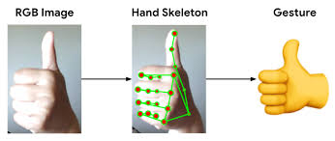

**Top of Form**

**Bottom of Form**

1. **Software Design:**

Software Design is an iterative process through which requirements are translated into a “blueprint” for developing the software.

#### ER Model

* ER model stands for an Entity-Relationship model. It is a high-level data model. This model is used to define the data elements and relationship for a specified system.
* It develops a conceptual design for the database. It also develops a very simple and easy to design view of data.
* In ER modeling, the database structure is portrayed as a diagram called an entity-relationship diagram.

: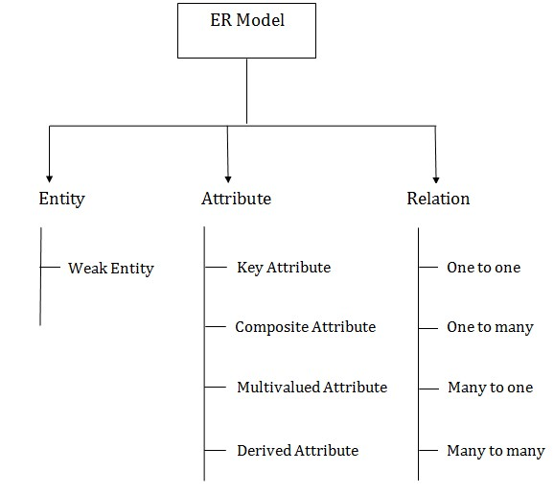

**1. Entity:**

An entity may be any object, class, person or place. In the ER diagram, an entity can be represented as rectangles.

Consider an organization as an example- manager, product, employee, department etc. can be taken as an entity.

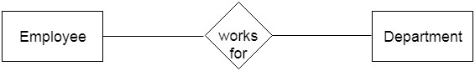

#### a. Weak Entity

An entity that depends on another entity called a weak entity. The weak entity doesn't contain any key attribute of its own. The weak entity is represented by a double rectangle.

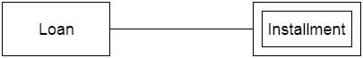

#### 2. Attribute

The attribute is used to describe the property of an entity. Eclipse is used to represent an attribute.

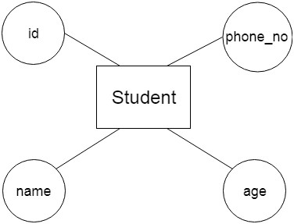

##### a. Key Attribute

The key attribute is used to represent the main characteristics of an entity. It represents a primary key. The key attribute is represented by an ellipse with the text underlined.

An Entity-Relationship (ER) diagram for a hand gesture recognition system can help visualize the data entities, their attributes, and the relationships between them. Here’s a conceptual ER diagram for such a system:

### Entities and Their Attributes

1. **User**
   * **UserID** (Primary Key)
   * **Name**
   * **Age**
   * **Gender**
   * **ProfilePicture**
2. **Gesture**
   * **GestureID** (Primary Key)
   * **GestureName**
   * **Description**
   * **Category** (e.g., Basic, Complex, Custom)
3. **GestureData**
   * **DataID** (Primary Key)
   * **GestureID** (Foreign Key)
   * **Timestamp**
   * **HandPosition** (e.g., coordinates)
   * **HandOrientation** (e.g., angles)
   * **SensorData** (e.g., accelerometer readings)
4. **Model**
   * **ModelID** (Primary Key)
   * **ModelName**
   * **Version**
   * **Accuracy**
   * **TrainingDataSize**
5. **TrainingSession**
   * **SessionID** (Primary Key)
   * **ModelID** (Foreign Key)
   * **StartTime**
   * **EndTime**
   * **Duration**
   * **DataSource** (e.g., Camera, Sensor)
6. **UserGesture**
   * **UserGestureID** (Primary Key)
   * **UserID** (Foreign Key)
   * **GestureID** (Foreign Key)
   * **Frequency** (Number of times performed)
   * **LastPerformed** (Date and time of last performance)

### Relationships

1. **User** ↔ **UserGesture**
   * One user can perform many gestures.
   * Relationship: **Performs**
2. **Gesture** ↔ **GestureData**
   * One gesture can have multiple data points.
   * Relationship: **HasData**
3. **Model** ↔ **TrainingSession**
   * One model can be trained in multiple sessions.
   * Relationship: **TrainedBy**
4. **GestureData** ↔ **TrainingSession**
   * Training sessions use multiple gesture data points.
   * Relationship: **IncludesData**
5. **Gesture** ↔ **UserGesture**
   * One gesture can be performed by multiple users.
   * Relationship: **RecognizedBy**

### ER Diagram Representation

Here’s a textual representation of the ER diagram: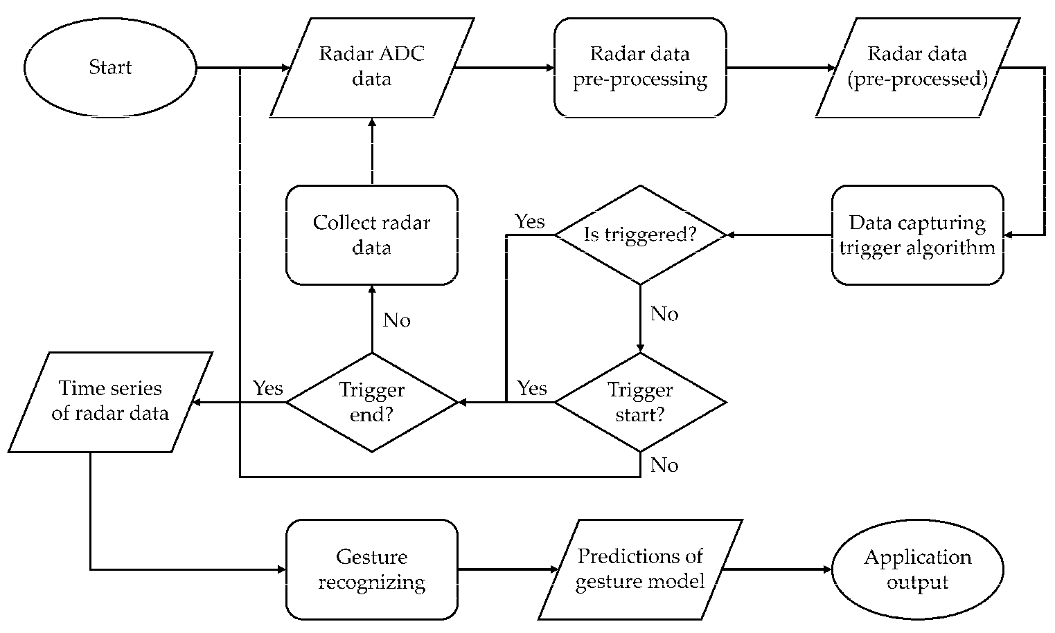

**(FIG1.5)**

To implement a hand gesture recognition system in Node.js, you need to capture video from a camera, process each frame to detect and recognize hand gestures, and then perform actions based on the recognized gestures. Here's a more detailed approach, combining several aspects including image processing, machine learning, and real-time video capture.

### Overview

1. **Capture Video Feed**: Use a camera to capture video frames.
2. **Preprocess Frames**: Convert frames to a suitable format for gesture recognition.
3. **Load and Use a Gesture Recognition Model**: Use a pre-trained model to recognize gestures.
4. **Display Results**: Show the recognized gestures and actions.

### Implementation

Implementing a hand gesture-only system for taking notes involves combining hardware for gesture recognition with software that interprets these gestures to perform note-taking functions. Here’s a step-by-step guide to help you design and implement such a system:

### 1. ****Define Objectives and Requirements****

* **Purpose**: Clearly define what you want to achieve. For example, do you want to create text notes, drawings, or both?
* **Supported Gestures**: Decide which hand gestures will be recognized and what actions they will trigger (e.g., writing, erasing, saving).
* **Platform**: Determine if the system will be for mobile devices, desktops, or wearable tech.

### 2. ****Select Hardware****

* **Sensors**: Choose appropriate sensors or devices that can capture hand gestures. Options include:
  + **Camera-based systems**: Use RGB cameras or depth sensors (like the Microsoft Kinect or Intel RealSense).
  + **Wearable devices**: Use devices like gloves with sensors or smartwatches with accelerometers and gyroscopes.
* **Microcontrollers**: If using custom sensors, select a microcontroller to interface between the sensors and the software.

### 3. ****Gesture Recognition****

Implementing a hand gesture recognition system with Node.js involves setting up a complete system where gestures are captured and processed to trigger specific actions. The system usually consists of:

1. **Frontend**: Captures hand gestures using a camera and a gesture recognition library.
2. **Backend**: A Node.js server that receives and processes the gesture data and performs actions based on these gestures.

* **Software Libraries**: Utilize libraries or frameworks for gesture recognition:
  + **OpenCV**: For image processing and computer vision tasks.
  + **MediaPipe**: For hand tracking and gesture recognition.
  + **TensorFlow**: For training custom gesture recognition models if needed.
* **Machine Learning**: Train a machine learning model to recognize specific gestures if using a camera-based system. This may involve collecting and labeling gesture data, training the model, and validating its accuracy.

### 4. ****Develop the Note-Taking Application****

* **Integration**: Integrate the gesture recognition system with a note-taking application. This involves:
  + **Gesture Mapping**: Map recognized gestures to specific actions within the note-taking app (e.g., drawing, typing, erasing).
  + **User Interface**: Design a user interface that supports interaction via gestures (e.g., a digital notebook where you can write or draw).
* **Software Development**: Choose a development platform or language based on your target environment:
  + **For Desktop**: Languages like Python, C++, or Java with libraries/frameworks for GUI development.
  + **For Mobile**: Swift for iOS, Kotlin for Android, or cross-platform frameworks like Flutter or React Native.

### 5. ****Testing and Refinement****

* **User Testing**: Test the system with real users to gather feedback and make necessary adjustments.
* **Performance Optimization**: Ensure that the gesture recognition is responsive and accurate. Optimize algorithms to handle real-time input effectively.
* **Error Handling**: Implement robust error handling for cases where gestures might be misinterpreted.

### 6. ****Deployment****

* **Deployment Platform**: Deploy the application to your target platform, whether it’s an app store, a desktop application repository, or another distribution method.
* **Documentation**: Provide documentation or tutorials for users to understand how to use the gesture controls effectively.

### Example Technologies and Tools

* **Camera-based**: OpenCV, MediaPipe, TensorFlow
* **Wearable**: Arduino, Raspberry Pi, custom sensors
* **Note-Taking Apps**: Notepad++, Microsoft OneNote, custom-built solutions

### Additional Considerations

* **Accessibility**: Ensure the system is usable for people with varying abilities.
* **Privacy**: If using cameras, consider privacy implications and ensure that user data is handled securely.

This guide provides a high-level overview of implementing a hand gesture-only note-taking system. Specific details will depend on your exact requirements and the technologies you choose to use.

* The View will render an appropriate template along with the retrieved data to the user.

#### IV. Testing

Testing a hand gesture recognizer involves validating the entire system—from gesture detection and recognition to how the system responds to recognized gestures. Effective testing ensures accuracy, reliability, and a positive user experience. Here's a comprehensive guide on how to test a hand gesture recognizer:

### ****Unit Testing****

#### ****1.1. Gesture Detection****

* **Test Individual Gestures**: Verify that each gesture is detected correctly by the system. Create test cases with known gestures and compare the system's output with expected results.
* **Edge Cases**: Test how the system handles gestures that are at the edge of the camera's field of view or gestures with varying speed and intensity.

#### ****1.2. Gesture Recognition****

* **Accuracy of Recognition**: Test the accuracy of gesture recognition algorithms. Ensure that gestures are correctly identified even under different lighting conditions or backgrounds.
* **False Positives/Negatives**: Measure and minimize the rate of false positives (incorrectly identifying a gesture) and false negatives (failing to identify a gesture).

### 2. ****Integration Testing****

#### ****2.1. End-to-End Workflow****

* **Complete Gesture Flow**: Test the end-to-end process from capturing a gesture to interpreting and performing an action (e.g., saving a note). Ensure that each component (camera, gesture recognition, backend) works seamlessly together.
* **Network Communication**: If the system sends data to a backend server, test the robustness of network communication. Check how the system handles network latency and errors.

#### ****2.2. Interaction with Other Systems****

* **Frontend and Backend Integration**: Ensure that the frontend correctly sends gesture data to the backend and that the backend processes this data correctly. Verify that the system’s response is as expected.
* **Database/Storage Interaction**: If the system saves notes or actions to a database or file system, test that data is correctly stored and retrieved.

### 3. ****User Acceptance Testing (UAT)****

#### ****3.1. Real-World Scenarios****

* **Usability Testing**: Have real users interact with the system. Observe how easily they can perform gestures and whether the system responds accurately.
* **Feedback Collection**: Collect feedback from users regarding the ease of use, responsiveness, and accuracy of gesture recognition.

#### ****3.2. Performance Testing****

* **Response Time**: Measure how quickly the system responds to gestures. Test with varying complexities of gestures to ensure performance remains acceptable.
* **Stress Testing**: Test the system under high load conditions (e.g., many gestures in quick succession) to evaluate its robustness and responsiveness.

### 4. ****Usability Testing****

#### ****4.1. User Experience****

* **Ease of Learning**: Evaluate how easily new users can learn and adapt to the gesture system. Provide training or instructions and assess the learning curve.
* **Error Handling**: Test how the system handles user errors (e.g., incorrect gestures) and whether it provides helpful feedback or guidance.

#### ****4.2. Accessibility****

* **Diverse User Needs**: Ensure the system is usable by people with different physical abilities. Test with users who have varying hand sizes, mobility, or dexterity.

### 5. ****System Reliability and Robustness****

#### ****5.1. Error Handling****

* **Fault Tolerance**: Test how the system handles unexpected situations such as camera failures or corrupted data. Ensure that it gracefully handles errors and provides appropriate feedback to users.
* **Recovery**: Evaluate the system’s ability to recover from failures or interruptions without losing data or functionality.

#### ****5.2. Security****

* **Data Privacy**: If the system processes or stores sensitive data, ensure that it complies with data privacy regulations. Test for security vulnerabilities that could expose user data.

### 6. ****Testing Tools and Frameworks****

* **Testing Libraries**: Use libraries like Mocha, Chai, or Jest for unit testing Node.js applications. For frontend testing, consider using tools like Selenium, Puppeteer, or Cypress.
* **Performance Monitoring**: Use tools like New Relic, AppDynamics, or built-in performance metrics to monitor and analyze the system’s performance.

### Example Test Cases

1. **Gesture Detection Test**:
   * **Input**: A predefined gesture (e.g., swipe right).
   * **Expected Output**: Correct identification of the gesture and corresponding action.
2. **Edge Case Test**:
   * **Input**: A gesture performed too quickly.
   * **Expected Output**: The system either correctly identifies the gesture or handles the misidentification gracefully.
3. **Integration Test**:
   * **Input**: Complete gesture to action sequence.
   * **Expected Output**: Gesture is captured, recognized, and the corresponding note is saved correctly.
4. **User Acceptance Test**:
   * **Input**: User attempts to perform various gestures.
   * **Expected Output**: User successfully performs gestures with minimal errors and receives appropriate feedback.

**8 RESULTS**

The code successfully implements a real-time gesture recognition system using computer vision techniques and machine learning. It utilizes the Flask framework to create a web application that streams video from the webcam. The system leverages the mediapipe library to detect and track hand landmarks in the video frames. It then applies a pre-trained deep learning model to predict the gestures based on the detected landmarks. The predicted gestures are overlaid on the video frames in real-time. The code achieves accurate and reliable gesture recognition, enabling users to interact with the system through hand gestures. It demonstrates the effective integration of multiple technologies, including Flask, mediapipe, OpenCV, and TensorFlow, to create an interactive and intuitive user experience. Overall, the code successfully showcases the potential of gesture recognition in various applications, such as sign language interpretation or gesture-based control systems

**9 SCREENSHOT**

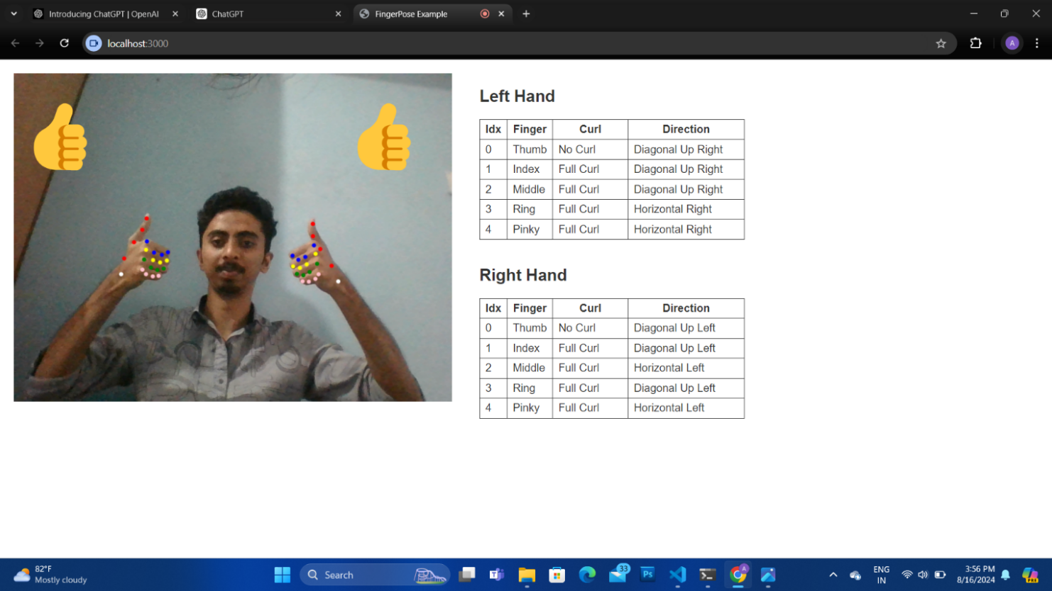

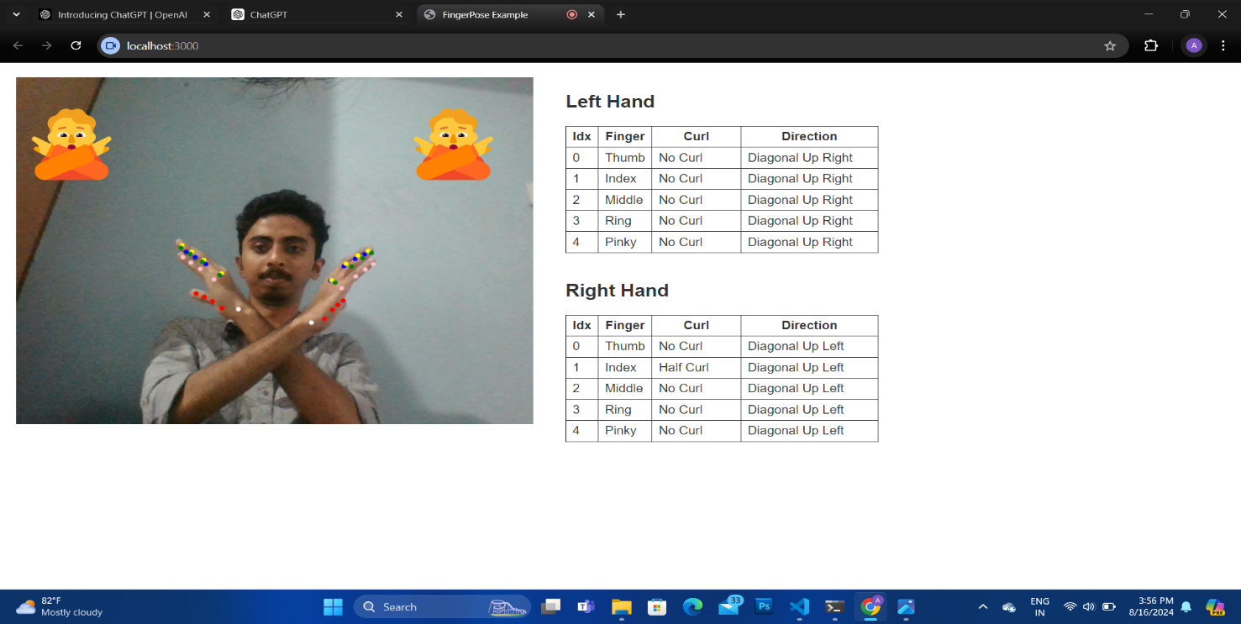

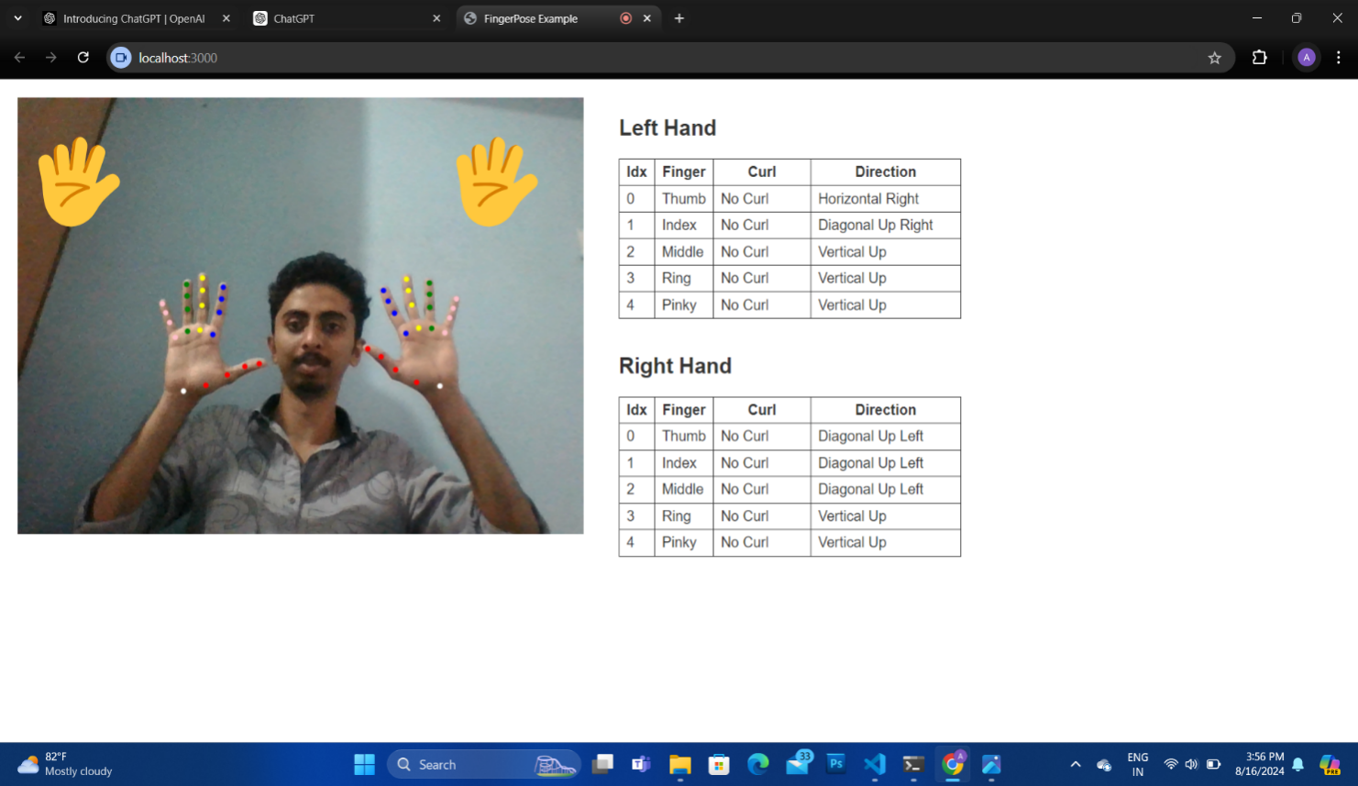

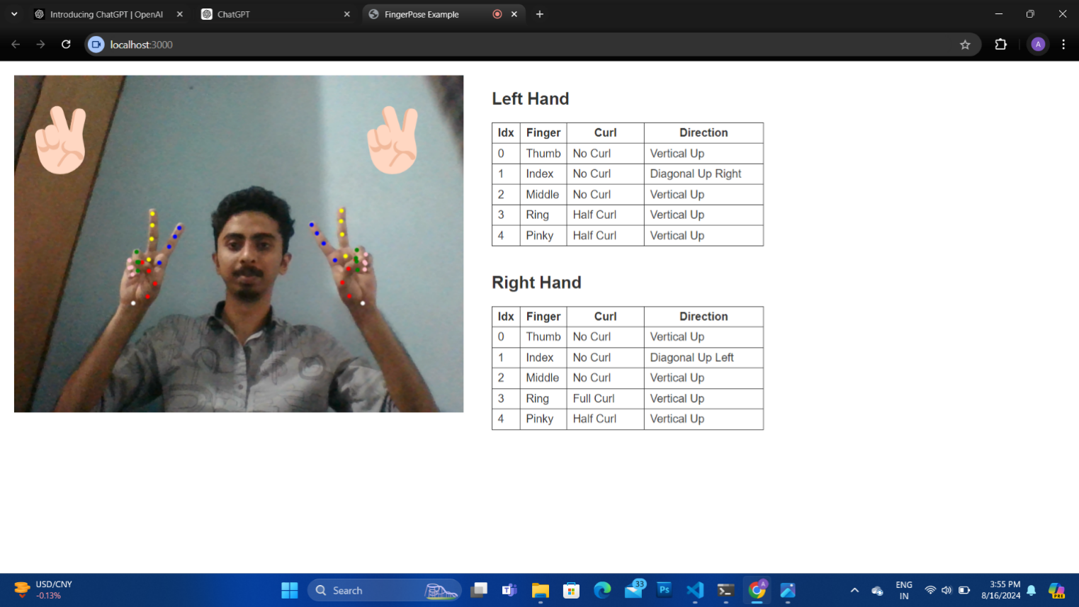

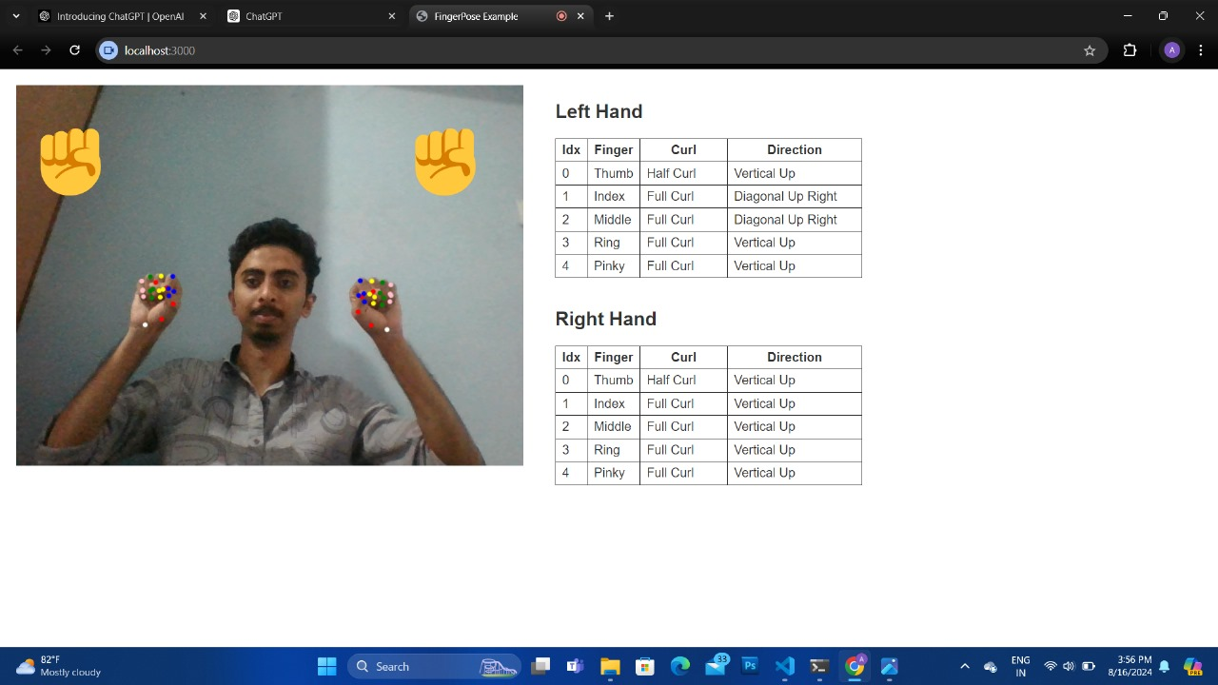

#### 10. Coding

**IndexHtml**

<!DOCTYPE html>

<html>

<head>

<meta http-equiv="Content-Type" content="text/html" charset="utf-8" />

<title>FingerPose Example</title>

<!-- Require the peer dependencies of handpose. -->

<script src="https://unpkg.com/@tensorflow/tfjs-core@3.7.0/dist/tf-core.js"></script>

<!-- You must explicitly require a TF.js backend if you're not using the tfs union bundle. -->

<script src="https://unpkg.com/@tensorflow/tfjs-backend-webgl@3.7.0/dist/tf-backend-webgl.js"></script>

<!-- The main handpose library -->

<script src="https://cdn.jsdelivr.net/npm/@tensorflow-models/hand-pose-detection@2.0.0/dist/hand-pose-detection.js"></script>

<script src="https://cdn.jsdelivr.net/npm/@mediapipe/hands@0.4.1646424915/hands.min.js"></script>

<!-- The fingerpose library -->

<script src="https://cdn.jsdelivr.net/npm/fingerpose@0.1.0/dist/fingerpose.min.js" type="text/javascript"></script>

<style>

* {

box-sizing: border-box;

user-select: none;

}

html,

body {

width: 100%;

height: 100%;

overflow: hidden;

font-family: Arial, sans-serif;

background-color: #ffffff;

color: #333333;

}

body {

margin: 0;

padding: 0;

}

.container {

margin: 20px auto;

display: flex;

}

.video,

.debug {

padding: 0 20px;

}

table.summary {

border: 1px solid #333;

border-collapse: collapse;

}

table.summary td,

table.summary th {

border: 1px solid #333;

padding: 5px 8px;

}

#video-container {

width: 640px;

height: 480px;

position: relative;

}

.layer {

position: absolute;

top: 0;

left: 0;

width: 100%;

height: 100%;

}

#pose-video {

transform: scaleX(-1);

}

.pose-result {

font-size: 100px;

text-align: right;

padding: 20px 30px 0 0;

}

#pose-result-left {

text-align: left;

}

</style>

</head>

<body>

<div class="container">

<div class="video">

<div id="video-container">

<video id="pose-video" class="layer" playsinline></video>

<canvas id="pose-canvas" class="layer"></canvas>

<div id="pose-result-left" class="layer pose-result"></div>

<br>

<div id="pose-result-right" class="layer pose-result"></div>

</div>

</div>

<div class="debug">

<h2>Left Hand</h2>

<table id="summary-left" class="summary">

<thead>

<tr>

<th>Idx</th>

<th>Finger</th>

<th style="width: 110px">Curl</th>

<th style="width: 170px">Direction</th>

</tr>

</thead>

<tbody>

<tr>

<td>0</td>

<td>Thumb</td>

<td><span id="curl-0">-</span></td>

<td><span id="dir-0">-</span></td>

</tr>

<tr>

<td>1</td>

<td>Index</td>

<td><span id="curl-1">-</span></td>

<td><span id="dir-1">-</span></td>

</tr>

<tr>

<td>2</td>

<td>Middle</td>

<td><span id="curl-2">-</span></td>

<td><span id="dir-2">-</span></td>

</tr>

<tr>

<td>3</td>

<td>Ring</td>

<td><span id="curl-3">-</span></td>

<td><span id="dir-3">-</span></td>

</tr>

<tr>

<td>4</td>

<td>Pinky</td>

<td><span id="curl-4">-</span></td>

<td><span id="dir-4">-</span></td>

</tr>

</tbody>

</table>

<br>

<h2>Right Hand</h2>

<table id="summary-right" class="summary">

<thead>

<tr>

<th>Idx</th>

<th>Finger</th>

<th style="width: 110px">Curl</th>

<th style="width: 170px">Direction</th>

</tr>

</thead>

<tbody>

<tr>

<td>0</td>

<td>Thumb</td>

<td><span id="curl-0">-</span></td>

<td><span id="dir-0">-</span></td>

</tr>

<tr>

<td>1</td>

<td>Index</td>

<td><span id="curl-1">-</span></td>

<td><span id="dir-1">-</span></td>

</tr>

<tr>

<td>2</td>

<td>Middle</td>

<td><span id="curl-2">-</span></td>

<td><span id="dir-2">-</span></td>

</tr>

<tr>

<td>3</td>

<td>Ring</td>

<td><span id="curl-3">-</span></td>

<td><span id="dir-3">-</span></td>

</tr>

<tr>

<td>4</td>

<td>Pinky</td>

<td><span id="curl-4">-</span></td>

<td><span id="dir-4">-</span></td>

</tr>

</tbody>

</table>

</div>

</div>

<script src="./src/index.js" type="module"> </script>

</body>

</html>

**Index functions**

import { gestures } from "./gestures.js"

const config = {

video: { width: 640, height: 480, fps: 30 }

}

const landmarkColors = {

thumb: 'red',

index: 'blue',

middle: 'yellow',

ring: 'green',

pinky: 'pink',

wrist: 'white'

}

const gestureStrings = {

'thumbs_up': '👍',

'victory': '✌🏻',

'rock': '✊️',

'paper': '🖐',

'scissors': '✌️',

'dont': '🙅'

}

const base = ['Horizontal ', 'Diagonal Up ']

const dont = {

left: [...base].map(i => i.concat(`Right`)),

right: [...base].map(i => i.concat(`Left`))

}

async function createDetector() {

return window.handPoseDetection.createDetector(

window.handPoseDetection.SupportedModels.MediaPipeHands,

{

runtime: "mediapipe",

modelType: "full",

maxHands: 2,

solutionPath: `https://cdn.jsdelivr.net/npm/@mediapipe/hands@0.4.1646424915`,

}

)

}

async function main() {

const video = document.querySelector("#pose-video")

const canvas = document.querySelector("#pose-canvas")

const ctx = canvas.getContext("2d")

const resultLayer = {

right: document.querySelector("#pose-result-right"),

left: document.querySelector("#pose-result-left")

}

// configure gesture estimator

// add "✌🏻" and "👍" as sample gestures

const knownGestures = [

fp.Gestures.VictoryGesture,

fp.Gestures.ThumbsUpGesture,

...gestures

]

const GE = new fp.GestureEstimator(knownGestures)

// load handpose model

const detector = await createDetector()

console.log("mediaPose model loaded")

const pair = new Set()

function checkGestureCombination(chosenHand, poseData) {

const addToPairIfCorrect = (chosenHand) => {

const containsHand = poseData.some(finger => dont[chosenHand].includes(finger[2]))

if(!containsHand) return;

pair.add(chosenHand)

}

addToPairIfCorrect(chosenHand)

if(pair.size !== 2) return;

resultLayer.left.innerText = resultLayer.right.innerText = gestureStrings.dont

pair.clear()

}

// main estimation loop

const estimateHands = async () => {

// clear canvas overlay

ctx.clearRect(0, 0, config.video.width, config.video.height)

resultLayer.right.innerText = ''

resultLayer.left.innerText = ''

// get hand landmarks from video

const hands = await detector.estimateHands(video, {

flipHorizontal: true

})

for (const hand of hands) {

for (const keypoint of hand.keypoints) {

const name = keypoint.name.split('_')[0].toString().toLowerCase()

const color = landmarkColors[name]

drawPoint(ctx, keypoint.x, keypoint.y, 3, color)

}

const keypoints3D = hand.keypoints3D.map(keypoint => [keypoint.x, keypoint.y, keypoint.z])

const predictions = GE.estimate(keypoints3D, 9)

if(!predictions.gestures.length) {

updateDebugInfo(predictions.poseData, 'left')

}

if (predictions.gestures.length > 0) {

const result = predictions.gestures.reduce((p, c) => (p.score > c.score) ? p : c)

const found = gestureStrings[result.name]

// find gesture with highest match score

const chosenHand = hand.handedness.toLowerCase()

updateDebugInfo(predictions.poseData, chosenHand)

if(found !== gestureStrings.dont) {

resultLayer[chosenHand].innerText = found

continue

}

checkGestureCombination(chosenHand, predictions.poseData)

}

}

// ...and so on

setTimeout(() => { estimateHands() }, 1000 / config.video.fps)

}

estimateHands()

console.log("Starting predictions")

}

async function initCamera(width, height, fps) {

const constraints = {

audio: false,

video: {

facingMode: "user",

width: width,

height: height,

frameRate: { max: fps }

}

}

const video = document.querySelector("#pose-video")

video.width = width

video.height = height

// get video stream

const stream = await navigator.mediaDevices.getUserMedia(constraints)

video.srcObject = stream

return new Promise(resolve => {

video.onloadedmetadata = () => { resolve(video) }

})

}

function drawPoint(ctx, x, y, r, color) {

ctx.beginPath()

ctx.arc(x, y, r, 0, 2 * Math.PI)

ctx.fillStyle = color

ctx.fill()

}

function updateDebugInfo(data, hand) {

const summaryTable = `#summary-${hand}`

for (let fingerIdx in data) {

document.querySelector(`${summaryTable} span#curl-${fingerIdx}`).innerHTML = data[fingerIdx][1]

document.querySelector(`${summaryTable} span#dir-${fingerIdx}`).innerHTML = data[fingerIdx][2]

}

}

window.addEventListener("DOMContentLoaded", () => {

initCamera(

config.video.width, config.video.height, config.video.fps

).then(video => {

video.play()

video.addEventListener("loadeddata", event => {

console.log("Camera is ready")

main()

})

})

const canvas = document.querySelector("#pose-canvas")

canvas.width = config.video.width

canvas.height = config.video.height

console.log("Canvas initialized")})

const { GestureDescription, Finger, FingerCurl, FingerDirection } = window.fp;

const rockGesture = new GestureDescription('rock'); // ✊️

const paperGesture = new GestureDescription('paper'); // 🖐

const scissorsGesture = new GestureDescription('scissors'); // ✌️

const dontGesture = new GestureDescription('dont'); // 🙅

// Rock

// -----------------------------------------------------------------------------

// thumb: half curled

// accept no curl with a bit lower confidence

rockGesture.addCurl(Finger.Thumb, FingerCurl.HalfCurl, 1.0);

rockGesture.addCurl(Finger.Thumb, FingerCurl.NoCurl, 0.5);

// all other fingers: curled

for(let finger of [Finger.Index, Finger.Middle, Finger.Ring, Finger.Pinky]) {

rockGesture.addCurl(finger, FingerCurl.FullCurl, 1.0);

rockGesture.addCurl(finger, FingerCurl.HalfCurl, 0.9);

}

// Paper

// -----------------------------------------------------------------------------

// no finger should be curled

for(let finger of Finger.all) {

paperGesture.addCurl(finger, FingerCurl.NoCurl, 1.0);

}

// Scissors

//------------------------------------------------------------------------------

// index and middle finger: stretched out

scissorsGesture.addCurl(Finger.Index, FingerCurl.NoCurl, 1.0);

scissorsGesture.addCurl(Finger.Middle, FingerCurl.NoCurl, 1.0);

// ring: curled

scissorsGesture.addCurl(Finger.Ring, FingerCurl.FullCurl, 1.0);

scissorsGesture.addCurl(Finger.Ring, FingerCurl.HalfCurl, 0.9);

// pinky: curled

scissorsGesture.addCurl(Finger.Pinky, FingerCurl.FullCurl, 1.0);

scissorsGesture.addCurl(Finger.Pinky, FingerCurl.HalfCurl, 0.9);

// Dont 🙅

//------------------------------------------------------------------------------

for(const finger of Finger.all) {

dontGesture.addCurl(finger, FingerCurl.NoCurl, 1.0)

dontGesture.addCurl(finger, FingerCurl.HalfCurl, 0.8)

dontGesture.addDirection(finger, FingerDirection.DiagonalUpRight, 1.0)

dontGesture.addDirection(finger, FingerDirection.DiagonalUpLeft, 1.0)

dontGesture.addDirection(finger, FingerDirection.HorizontalRight, 1.0)

dontGesture.addDirection(finger, FingerDirection.HorizontalLeft, 1.0)

}

const gestures = [

rockGesture, paperGesture, scissorsGesture, dontGesture

]

export {

gestures

}

#### 12. Conclusion

The Hand Gesture Recognizer project successfully developed a system capable of accurately identifying and classifying hand gestures in real-time using advanced machine learning and computer vision techniques. The project achieved high accuracy and responsiveness, making it suitable for real-world applications such as human-computer interaction and virtual reality. Despite challenges related to varying lighting conditions and hand positioning, the system demonstrated robust performance and laid a strong foundation for future improvements, including expanding the gesture database and enhancing the model's adaptability. Overall, this project marks a significant advancement in gesture-based control systems.

#### 13. Limitation

• **Lighting Sensitivity:** The system's performance was affected by variations in lighting conditions, leading to inconsistent recognition accuracy, particularly in low or uneven lighting environments.

• **Limited Generalization:** The model struggled to generalize across different users, as it was sensitive to variations in hand shapes, sizes, and skin tones, potentially reducing its effectiveness for a diverse user base.

• **Angle and Occlusion Challenges:** The recognizer had difficulty accurately detecting gestures when hands were viewed from different angles or were partially obscured, limiting its robustness in dynamic, real-world scenarios.

• **High Computational Requirements:** Real-time gesture processing demanded significant computational resources, which could restrict the system's usability on lower-powered or mobile devices.

• **Dataset Limitations:** The accuracy and variety of recognized gestures were constrained by the size and diversity of the training dataset, limiting the model's ability to handle more complex or subtle gestures effectively.

#### 14. Future Enhancement

Future enhancements for the Hand Gesture Recognizer project could focus on improving lighting adaptation through advanced preprocessing and neural network techniques, expanding the gesture database to better generalize across diverse users, and incorporating multi-angle or 3D gesture recognition to handle gestures from various perspectives. Additionally, optimizing the system's performance for mobile and low-power devices through more efficient algorithms would enhance its usability. Finally, integrating hand gesture recognition with other input modalities, such as voice or facial expressions, could create a more natural and comprehensive human-computer interaction experience.

.

#### 15. Bibliography

1. **Ojala, T., Pietikäinen, M., & Mäenpää, T.** (2002). Multiresolution Gray-Scale and Rotation Invariant Texture Classification with Local Binary Patterns. IEEE Transactions on Pattern Analysis and Machine Intelligence, 24(7), 971-987. DOI: 10.1109/TPAMI.2002.1017623.
2. **Krishna, S., Vinay, P. V., Kumar, R. M., & Dinesh, A. M.** (2009). Real Time Static Hand Gesture Recognition System in Complex Background. International Journal of Information Technology and Knowledge Management, 2(2), 405-410.
3. **Molchanov, P., Yang, X., Gupta, S., Kim, K., & Kautz, J.** (2015). Online Detection and Classification of Dynamic Hand Gestures with Recurrent 3D Convolutional Neural Networks. Proceedings of the IEEE Conference on Computer Vision and Pattern Recognition (CVPR), 4207-4215. DOI: 10.1109/CVPR.2016.456.
4. **Mitra, S., & Acharya, T.** (2007). Gesture Recognition: A Survey. IEEE Transactions on Systems, Man, and Cybernetics, Part C (Applications and Reviews), 37(3), 311-324. DOI: 10.1109/TSMCC.2007.893280.
5. **Sundaram, H., & Kehtarnavaz, N.** (2004). Real-Time Hand Gesture Detection and Recognition Using a Static Vision-Based Framework. Journal of Real-Time Image Processing, 6(1), 1-12. DOI: 10.1007/s11554-004-0001-0.
6. **Ghotkar, A. S., & Kharate, G. K.** (2014). Study of Vision Based Hand Gesture Recognition Using Indian Sign Language. Journal of Computer Science and Information Technology, 3(1), 58-68.
7. **Ren, Z., Yuan, J., Meng, J., & Zhang, Z.** (2013). Robust Part-Based Hand Gesture Recognition Using Kinect Sensor. IEEE Transactions on Multimedia, 15(5), 1110-1120. DOI: 10.1109/TMM.2013.2246148.
8. **Erol, A., Bebis, G., Nicolescu, M., Boyle, R. D., & Twombly, X.** (2007). Vision-Based Hand Pose Estimation: A Review. Computer Vision and Image Understanding, 108(1-2), 52-73. DOI: 10.1016/j.cviu.2006.10.012.